2022 ABS Regional Polo Shirt Order Form
Orders and payment due: May 15, 2022

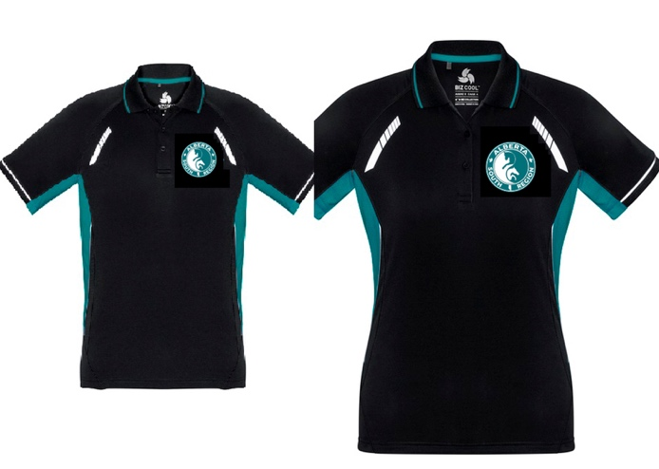

Look neat and tidy in these ABSR polo shirts, an easy way to look your best in clinics, lessons, testing and other Pony Club events.

Size Sheet
Youth Modern fit | 4 | 6 | 8 | 10 | 12 | 14 | 16
Garment ½ chest (in) | 14.2 | 15 | 15.7 | 16.5 | 17.3 | 18.1 | 19.3
Ladies Modern fit | 2 (XS) | 4 (S) | 6 | 8 (M) | 10 | 12 (L) | 14 | 16 | 18 | 20
Garment ½ chest (in) | 17.3 | 18.3 | 19.3 | 20.3 | 21.3 | 22.2 | 23.2 | 24.4 | 25.6 | 26.8
Men Modern Fit | S | M | L | XL | 2XL | 3XL | 5XL
Garment ½ chest (in) | 20.7 | 21.9 | 23 | 24.6 | 26.2 | 27.8 | 30.9

https://cdn.fashionbizapps.nz/stylesheets/attachments/000/024/757/original/P700MS_P700LS_P700KS_CA_2017.pdf

To compete your outfit, we also have baseball hats available, one size fits all!

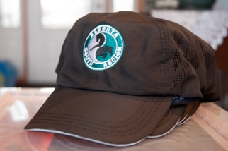

This lightweight polyester performance cap comes with a built-in woven sweatband made of water repellent polyester. Features side mesh panels, giving the cap extra breathability. The low- profile build of the cap gives it a casual, athletic look for everyday wear.

2022 ABS Regional Polo Shirt Order Form
Orders and payment due: May 15, 2022

Order FORM
 |  |  |  |  |  |  |  |  |  |  | Price each | Total # | Total Price
 | YOUTH SIZES
Youth |  | 4 | 6 | 8 | 10 | 12 | 14 | 16
 |  |  |  |  |  |  |  |  |  |  | $ 30.00
 | LADIES SIZES
Ladies | 2 (XS) | 4 (S) | 6 | 8 (M) | 10 | 12 (L) | 14 | 16 | 18 | 20
 |  |  |  |  |  |  |  |  |  |  | $ 35.00
 | MEN SIZES
Men | S | M | L | XL | 2XL | 3XL | 5XL
 |  |  |  |  |  |  |  |  |  |  | $ 35.00
 | BASEBALL HATS
 | One size only |  |  |  |  |  |  |  |  |  | $ 10.00
TOTAL ORDER

NAME: ____________________________________ BRANCH: ____________________________________

Email: _____________________________________

For more information and to submit your order form: Annette.buis@gmail.com

Payment can be made through e-transfer at: cpc.absr.treasurer@gmail.com

Your order can be picked up in Calgary (Bearspaw area) or we can arrange for pickup at one of the upcoming Regional events.

