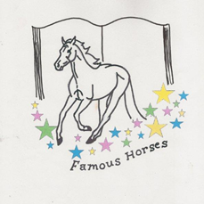
24th NATIONAL QUIZ 2011
HOSTED BY ALBERTA CENTRAL REGION
OCTOBER 7TH - 10TH CALGARY, ALBERTA
REGISTRATION IN PRINCIPAL

Please complete and email to: cpc_quiz_2011@hotmail.ca before June 30, 2011.
This will help our Quiz committee in planning all activities. The National Quiz 2011
Committee thanks you for your cooperation.

REGION:
CONTACT PERSON:
POSITION:
ADDRESS:
PHONE:
EMAIL:

Chaperone Information: How many chaperones will you be sending? _________
C Team Information (Teams of four): (Please circle Yes or No)
Will your Region be sending a C Team? Yes/No
# of Females_______________# of Males_______________

A/B Team Information (Teams of three or four): (Please circle Yes or No)
Will your region be sending an A/B Team? Yes/No A Partial team? Yes/No
# of Females_______________# of Males_______________

Affiliate Team Information (Teams of two or three): (Please circle Yes or No)
Will your Region be sending an Affiliate Team? Yes/No A Partial Team? Yes/No
# of Females_______________# of Males_______________

Additional Entries: Would you be interested in sending additional members? Yes/No
If so, how many participants at each level? C ______ A/B ______ Affiliate ______
Note: There will be no scramble teams at C level.

Special Needs Requirements (please specify below)

The Official Entry Forms, fees and all required documents are due by August 31, 2011.

