FOOT AND SHOEING – B

Instructor’s Guide

Part I –Function of Foot
Purpose
- Know the six function of the foot
- Begin learning the details of each function
Teaching Suggestions
- Student brainstorm session → Ask “Can you think of the functions of the foot?” See how many they can come up with without being told/looking

(USAB – 274-275)
- Weight Bearing | - weight carried mostly on hoof wall and on frog when sinks into soft ground  - the sensitive laminae is firmly affixed to the coffin bone → the sensitive laminae and insensitive laminae of the wall hook together like Velcro → downward weight of horse is transferred from coffin bone to hoof wall (MHP – 10)  - effectiveness of weight transfer reliant on strength of bond between sensitive and insensitive laminae  - sole can bear some weight but its main function is to protect internal structures
- Absorbing Shock | - works along with the joints and angles of the legs to absorb shock  - weight descends on foot →digital cushion is compressed between bones and the frog/sole → spreads out and puts pressure on lateral cartilages and walls → sole momentarily flattens and heels spread (MHP – 14)
- Pumping Blood | - contraction of muscles usually helps move blood back to heart  - lower leg and foot are long way from hear and do not have muscles so require a different mechanism for moving blood → foot acts as a pump  - blood enters foot through digital arteries → blood vessels run through plantar cushion  - every step: plantar cushion squeezed between coffin bone, lateral cartilages and frog → the veins in the cushion are compressed → blood gets pumped back up the leg toward the heart  - the veins leading back to heart have one way valves so that the blood cannot flow back downhill to the foot  - because the process requires compression and release of pressure on the plantar cushion, circulation is impaired during prolonged inactivity
- Traction | - frog helps prevent slipping on hard ground (rubbery)  - arched shape of sole helps stabilize foot on soft ground  - front edge of foot digs in as it breaks over
- Protection | - hoof wall, sole and frog are insensitive and protect the softer, sensitive parts inside  - insensitive components can tolerate concussion, abrasion, heat and cold  - periople protects from moisture loss
- Growth and Repair | - foot is always repairing itself → dead cells and those worn away  - growth from the corium  - rate of growth: ¼ - 3/8 inch per month  - changes in growth rate can result in “rings”  - growth rate effected by  - nutrition  - metabolism  - health  - climate  - MHP – 10 →“exercise increases blood flow in the foot and usually results in faster growth.”

Part II -- Structures of the foot
Purpose
- Identify the basic structures of the foot
- Begin learning the functions of each part
Teaching Suggestions
- Use diagrams found on page 6 to locate all the structures as they are discussed
- Start at the top front of the foot and work down and inwards
- Review the lists of three bones, three tendons and one ligament

NOTE: every source has slightly different terminology for the different structures. Wherever possible those differences have been identified
STRUCTURE | DESCRIPTION/FUNCTION
Perioplic Ring (KYH – 6) | - around the hoof above the coronet band  - secretes the periople
Periople (USAB – 256) | - thin varnish outer layer of hoof  - keeps moisture in
Coronary Band (USAB – 255) | - outer band of tissue at the hairline  - hoof grows from here  - less sensitive than the corium more sensitive than other exposed structures
Wall (USAB – 255) | - hard outer shell of the hoof  - made of small hair-like tubules called “insensitive laminae”  - most of the horse’s weight is born by the hoof wall  - MHP divides the wall into three parts  - periople/tectorum  - outer varnish or protective casing around the hoof  - tubules  - fibers that make up most of the hoof  - run parallel to each other and perpendicular to coronary band  - hollow and capable of holding moisture  - epidermal (insensitive) laminae  - “leaves” extending inward which interlock with sensitive laminae
Bars (MHP – 11) | - the height of the bar may be referred to as “buttress”  - function of the bars  - help absorb shock  - allow foot to expand under pressure  - reinforcement to prevent the wall contracting (KYH – 7)  - the angle formed between the bars and the wall is called “seat of corn” – an area which a shoe may press on if not reset early enough
White Line (NZ2 – 212) | - narrow ring of lighter, softer horn forming the junction between wall and sole and between sensitive and insensitive parts of the foot
Corium (KYH – 6 and MHP – 10) | - also known as “quick” (MHP)  - sensitive and blood rich  - provides moisture to the hoof wall  - keeps the foot warm via blood flow  - used without a qualifying location often refers to the deep tissue beneath the coronary band  - produces horn and periople  - subnamed according to the outer structure it nourishes  - coronary corium (MHP)  - perioplic corium (MHP)  - laminar corium  - KYH - same thing as sensitive laminae  - MHP – nourishes the sensitive laminae  - covers outer surface of the pedal bone  - corresponds to the inside of the hoof wall  - interlock with the insensitive laminae to hold the pedal bone in position (like Velcro)  - corium of the sole (sensitive sole) (KYH)  - covers lower surface of the pedal bone  - corium of the frog (sensitive frog) (KYH)  - covers the lower surface of the plantar cushion
Sensitive Laminae (MHP - 10 → dermal laminae) | - tiny hair-like tubules growing from the surface of the coffin bone  - interlock with the insensitive laminae → suspends the coffin bone in a strong, hard, protective casing that can flex under pressure  - has blood and nerve supply
Coffin Bone (Pedal Bone or 3rd phalanx) (USAB–254) | - the major bone of the foot  - supports the weight of the horse  - porous bone →lightness to foot (HN – 153)
Navicular Bone (distal sesamoid) (USAB – 254) | - small wedge-shaped bone  - under the back of the coffin bone (between short pastern bone(2nd phalanx) and coffin bone (3rd phalanx))  - acts as a fulcrum for the deep digital tendon (KYH – 5)  - located at the joint of the coffin and short pastern bone (HN - 154)
Navicular Bursa (USAB – 254) | - fluid filled sac cushioning the navicular bone and deep flexor tendon  - located between the navicular bone and the deep flexor tendon
Lateral Cartilages (USAB – 256) | - wing shaped cartilages  - attach to the sides of the coffin bone (VN – 232) and extend from upper sides of coffin bone and form the flexible bulbs of the heels  - located on each side of the rear of the coffin bone  - aid in the expansion of the foot  - the top edge extends above the coronary band → feels soft and pliable in young horses (MHP – 14)
Bulbs of heel (USAB – 256) | - formed by the lateral cartilages  - supported by the rear of the digital cushion (MHP – 14)
Digital Cushion (pedal or plantar cushion) | - spongy structure above the frog, between lateral cartilages the wings of the coffin bone (HN – 155)  - extends beneath the navicular bone and is similar in shape to frog (HN – 155)  - fibrous/fatty extending rearward to support the bulbs of the heel (MHP – 14)  - contains blood vessels (USAB – 275)  - pressure on cushion helps pump blood back up the leg with each step (USAB – 255)
Frog | - rubbery, wedge shaped structure (USAB – 256)  - lies between the heels (USAB – 256)  - central cleft (middle) and collateral clefts (down sides)  - Functions of the frog (HN- 152)  - shock absorber  - anti-slip device  - partial support of coffin bone and support to the navicular bone  - heel expander → disperses shock of impact outwards  - Assists in circulation of blood
Sole (USAB – 256) | - ground surface of hoof (inside the wall)  - should be arched or concave not flat  - Insensitive Sole  - outer layer  - no blood or nerve supply  - Sensitive Sole  - deep layer next to the underside of coffin bone  - has blood and nerve supply
Extensor Tendon (HN – 154) | - originates from muscles above knee and hock  - runs down the front of the leg, over the fetlock and pastern joints and attaches to the pointed centre of the upper border of the coffin bone  - straightens the limb and lifts the toe
Deep Flexor Tendon (HN – 154; USAB – 254) | - runs down the back of the cannon between the superficial flexor tendon and suspensory ligament  - passes below the navicular bone and attaches to the lower part of the coffin bone. It is broad and fan shaped where it passes under the navicular bone  - bends the joint of the coffin and short pastern bones (MHP – 8 states that flexor tendons attach the flexor muscles of the upper leg with the bones of the lower leg)
Superficial Flexor Tendon (HN – 154) | - runs down the back of the cannon bone branches in two and attaches to the lower part of the long pastern bone and the upper part of the short pastern bone  - bends the leg and joints
Suspensory Ligament (HN – 154) | - ligament runs between splint bones and lies close behind the cannon  - divides into two bands each of which attaches to the corresponding sesamoid bone  - some fibres pass over the pastern and reinforce the extensor tendon (HN – 154). There is no diagram available which clearly shows this ligament running into and connecting within the foot. Veterinary notes page 233 does show a “collateral (suspensory) ligament of the navicular bone attaching to the top of the navicular bone”.
3 bones of the foot | - Pedal bone (third phalanx or coffin bone)  - Navicular bone  - Short Pastern (second phalanx)
3 tendons of the foot | - Extensor Tendon  - Deep digital flexor tendon  - Superficial flexor tendon
Ligament of the foot | - Suspensory ligament

DIAGRAMS OF THE FOOT

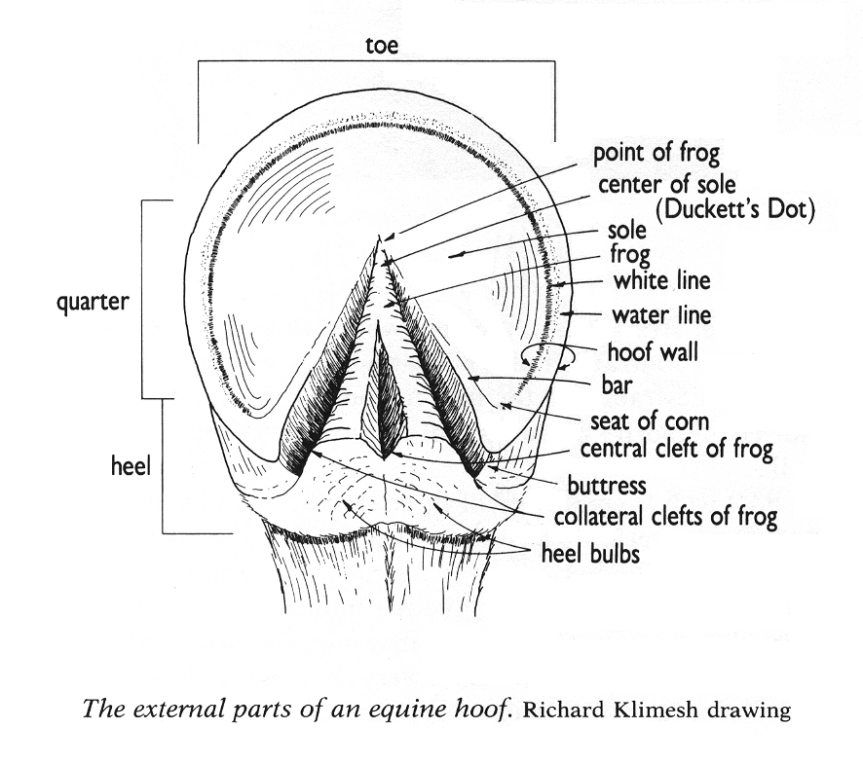
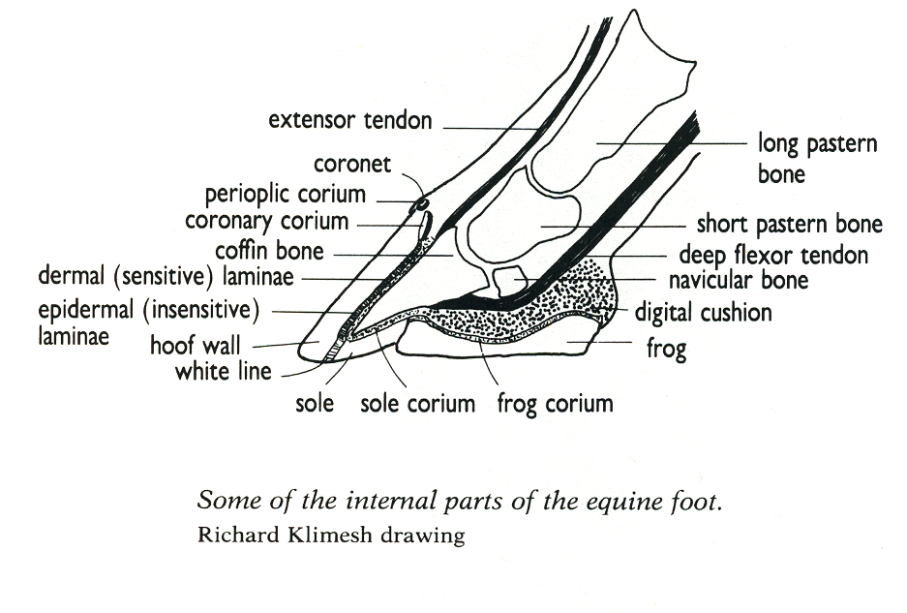
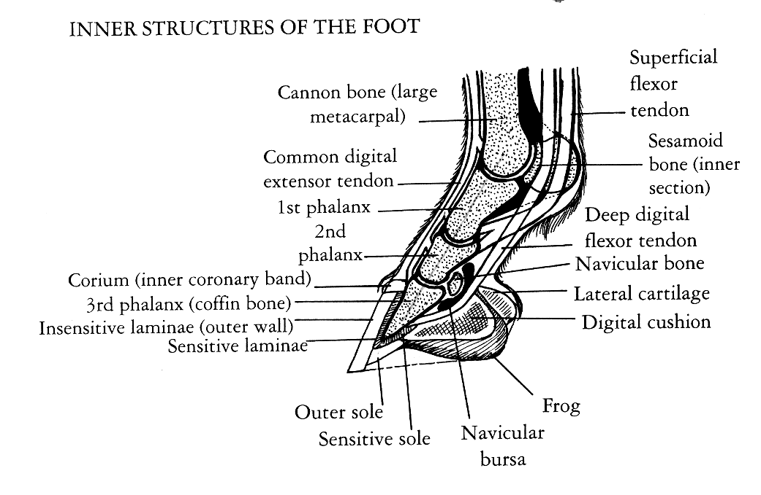
Maximum Hoof Power - 11
Maximum Hoof Power - 11
USPC A/B - 255

Part III – Care of the Foot
Purpose
- Understand the care of the shod and unshod hoof
Teaching Suggestions
- Brainstorm points of general foot care
- Identify the three main times a horse may be without shoes and the special requirements for each.
- The Hoof Examination Routine should be reviewed so students know what they should be looking for when they examine a shoe but it is unlikely they would be asked a question regarding the specific steps in an examination situation. It is more likely they would be asked a question such as “When you examine your horse’s feet, what do you look for?”

FOOT CARE
General | - Clean feet daily (MH – 233)  - Daily check the condition of feet and shoes (MH – 233)  - Look for signs of thrush (MH – 233)  - Book farrier in good time (MH – 233)  - Trim every 4-6 weeks (MH – 377)
Horse keeping to promote healthy feet  MHP 218-222  NB this is not included in student study guide as it provides very detailed information elaborating on the 5 main points above | - avoid frequent wet/dry cycles (frequent baths, frequent exposure to mud followed by standing in sun and drying) → stressful moisture expansion/contraction that can damage hoof structures  - keep stalls dry  - provide turnout areas that are not muddy  - minimize bathings and other wet-dry episodes such as hosing legs and then putting horse in stall with dry sawdust bedding  - use hoof dressing discriminately  - use hoof sealer when appropriate, during the wet seasons, if the horse must be bathed frequently, show signs of cracking or lots of rasping to wall during trimming (MHP 162-163)  - dry/cracked heels: rub a product containing animal fat (lanolin/fish oil) into heels daily (petroleum based products may actually remove moisture)  - exercise: ride or minimum two hours turnout (avoid footing that could result in foot damage)  - ensure horse is getting nutrients needed for healthy hooves  - keep horse at appropriate weight (minimize risk of problems such as laminitis)  - in winter hoof growth slows so if horse is barefoot avoid abrasive footing (MHP – 156)
The Unshod Foot  (MH – 231) | - properly trimmed approximately every six weeks (MHP – 18)  - watch that the hoof has worn too short or become broken (MHP – 160)  - Working  - avoid flinty or gritty footing  - check regularly by farrier  - even surface to the ground  - attention for splitting and cracking  - At Grass  - beneficial to remove shoes from horse where rest exceeds one month  - hooves grow without interference of nails  - farrier to control natural growth and correctly shape and balance (every 4-6 weeks)  - not beneficial if ground is hard or horse has flat soles  - Youngstock  - regular farrier attention to watch for uneven growth  - remedial action for defects and ensure proper shape and balance
The Shod Foot | - continue basic foot care  - monitor moisture balance in hooves that must where pads for an extended period of time (MHP – 219)
Hoof Examination Routine  (MHP – 225) | - do this routine when horse is healthy so you have a baseline to compare it to should he be unwell  - which leg is resting  - are front legs in a vertical position (not ahead or behind a normal position)  - are hind legs ahead or behind a normal position  - is he reluctant to walk  - wipe mud or manure off the hood wall and coronet  - pick out all of his hooves  - note any sensitivity in the clefts of frog (including central cleft) while using hoofpick to clean them  - look for imbedded rocks, splinters, nails etc in any part of foot including coronet  - test each branch of the shoe to see if it is loose  - sight down the bottom surface of the shoe to see if it is still flat  - note if the shoe slipped or twisted off to one side  - note if the shoe has slipped backward  - check the clinches to see if they are tight  - look for signs of injury on the coronary band, bulbs or lower leg

Part IV – Shoeing Tools
Purpose
- Recognize farrier tools and specify use
Teaching Suggestions
- Where possible, bring the tools to look at.
- Combine this section with Part V (hot shoeing steps) and do a mock hot shoeing (on a person if you are in a classroom).

Name | Diagram  (MH) | Description
Buffer or Clinch Cutter | 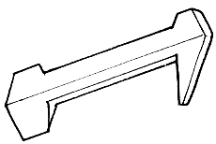 | - used to raise and cut clenches when removing shoes
Pincers or Shoe Pullers | 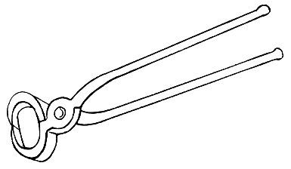 | - pliers that grip the shoe and pry it off  - also used to remove nails  - both edges are thin
Rasp | 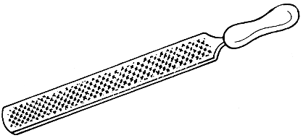 | - sharp heavy file to rasp and smooth feet and smooth clenches
Drawing knife or Hoof knife | 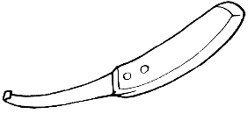 | - used to pare away excess sole or trim the frog  - making notches for clips (HN – 162)
Hoof Cutter/Trimmers or Nippers | 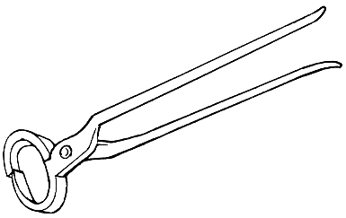 | - shaped like shoe pullers but with sharpened edges (usually only one is thin)  - used to nip off excess wall
Pritchel | 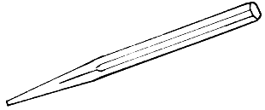 | - metal spike used to hold a hot shoe  - make nail holes (HN – 162)
Hammer | 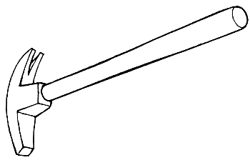 | - driving nails  - twisting off points when through the hoof (HN – 161)
Nail Clencher | 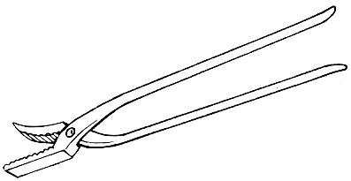 | - bends and flattens clenches into hoof wall
Crease Nail Puller |  | - for grasping and pulling nails that are set in the crease (MHP – 27)
Diagrams from MH edition 10 page 211 descriptions from USC – 253

Part V – Hot Shoeing vs. Cold Shoeing
Purpose
- Ability to discuss hot shoeing versus cold shoeing
- Know the steps of hot shoeing (6)
Teaching Suggestions
- Combine with tools and do a mock hot shoeing.
- Review advantages and disadvantages of both shoeing types.

Steps in Hot Shoeing (MH – 224 –226; USC – 254)
STEP | TOOLS | PROCEDURE
- Removal | buffer, driving hammer and pincers | - remove nails with buffer and driving hammer  - pry off shoe with pincers
- Preparation | knife, hoof cutter and rasp | - excess growth of hoof is removed with cutters  - excess sole cut back with knife  - ragged parts of frog trimmed away  - wall rasped to make level bearing surface
- Forgeing | iron, anvil/hammer, pritchel | - iron is selected  - iron shaped on the anvil with hammer  - nail holes stamped with pritchel  - clips drawn with hammer/anvil
- Fitting | pritchel, hammer/anvil | - hot shoe carried to foot with pritchel  - shoe held to foot to “sear” to show where hoof touches shoe  - adjustments are made and rechecked until shoe fits perfectly
- Nailing on | nails, hammer and nail block | - shoe is cooled  - first nail driven in usually at toe  - ends of nails twisted off  - may be driven against a nail block
- Finishing | clenchers, rasp, hammer | - clenches are tidied and finished with hammer and/or clencher and lightly rasped over  - clips are given a tap  - rasp run around edge where wall meets shoe to reduce cracking

Comparison of Hot and Cold Shoeing (USC – 254)
 | DESCRIPTION | ADVANTAGES | DISADVANTAGES
Cold Shoeing | - keg shoes are shaped and nailed on without being heated  - bent by being hammered on an anvil | - wide variety are available  - somewhat quicker | - can be shaped but not extensively modified  - nail holes are in same place which can result in weak/damaged spot on hoof (HN – 15)
Hot Shoeing | - forge is used to heat iron and make or modify shoes | - more modifications can be made  - make shoes not available as a key shoe  - shoe can be seared to detect fitting problems | - time consumption

Part VI – Shoeing Quality
Purpose
- Identify and discuss characteristics of good and bad shoeing
- Know the indications of need for reshoeing
Teaching Suggestions
- Review “Signs of Good Shoeing” and “Signs of Poor Shoeing”
- The section “Considerations Affecting Shoeing Quality” is a much more detailed listing of factors affecting shoeing quality. Review of this section may answer questions students have regarding signs of good shoeing.

Shoeing Quality
Signs of Good Shoeing  (USC – 256) | - shoe is the right size for the hoof. Shoe has been fitted to the foot not the foot rasped down to fit the shoe  - frog and sole have not been cut away too much and the frog touches on soft ground  - type of shoe is suitable for the work the horse is used for, and the weight of the iron is suitable for the size of the horse  - the heels of the are neither to short nor too long  - the foot is balanced so that it lands evenly, without twisting or rocking  - the angle of the hoof is the same as the angle of the pastern  - the clinches are smooth, tight and in an even line neither too high nor too low  - the nails are the correct size and driven home (fit and fill the nail holes)  - the clips have been neatly cut and the clips are well drawn and fitted (MH – 227)  - the farrier has taken time to watch the horse move before and after shoeing and has examined the wear pattern on the old shoes  - the farrier has considered conformation, way of moving and soundness or movement problems as well as the way in which the horse is used
Signs of Poor Shoeing | - cutting away too much frog  - cutting away too much sole  - shoes that are too small, especially if the toe has been “dumped” or rasped down so that it looks like it has been chopped off. If the heels of the shoe are too short they do not provide adequate support.  - rasping too much of the outer surface of the hoof (removes periople)  - clinches that are sharp, uneven or very low  - farrier who is in a hurry, who does not take time to watch the horse move or who rasps the foot down to fit the shoe

Considerations Affecting Shoeing Quality
The following is a more detailed list of considerations affecting the quality of shoeing. All considerations fall into one or more of the above nine points but are arranged below according to procedure (MHP – 42-56)

Hoof Preparation should consider
Balance | - geometric balance of the foot at rest (static) and balance of the foot in motion (dynamic)  - the parallel angles of the hoof at heel and toe (a line drawn down from the coronet band down the front of the toe should be parallel to a line drawn down from the coronet band at the heel)  - the hoof and the pastern are at the same angle (viewed from the side, a line drawn down the center of the pastern bone extending to the ground should be at the same angle as the hoof)  - side to side balance of the foot: both inside and outside walls of the foot should take weight evenly.
Length | - toe length is measured from where the soft coronet meets hard hoof  - desired length varies given horse’s conformation and breeding  - a horse to be left barefoot should have the toe ¼” longer than if the horse was to be shod
Levelness | - related to balance  - the bottom of hoof wall should be level so it makes perfect contact with a smooth ground surface or a flat shoe  - a farrier may purposely remove a portion of hoof wall for a specific reason
Sole | - sole should be pared to make concave but not so thin to cause horse to be sore if walking on gravel  - if the sole is left too thick it reduces hoof expansion, inhibit natural springing action of the hoof capsule (important in shock absorption) and may prevent farrier from trimming toe sufficiently  - bars should not be weakened by excessive trimming but long deformed horn should be removed
Frog | - smoothly pared  - trim clefts of frog at heels so that the hoof can self-clean  - not necessary or desirable for frog to bear weight when the horse stands on level ground
Shape | - flares and other deviations of the foot should be removed to encourage growth of normal hoof shape
Symmetry of Hoof Pairs | - generally toe lengths should be equal (e.g., both forefeet have equal toe lengths) but given conformation there may be differences. Farrier may decide to make them both equal or may trim and shoe differently so that they move the same (decision will be based on other factors such as balance described above).
Shoe Preparation Should Consider
Selection | - appropriate for size of horse and hoof  - strong enough to support the horse’s weight but not unnecessarily heavy  - adequate protection, support and traction  - nail heads protected from wear by being set in either a crease or a hole
Fit | - shoe should follow natural shape of the properly prepared hoof  - see hoof expansion
Hoof Expansion | - viewed from above with foot on the ground 1/16 to 1/8 of shoe will be visible from the quarters back to the heels allow for expansion as horse moves and hoof grows  - upright hooves need less expansion room than flatter spread out hooves
Heel Support | - heel of the shoe should be below the midline of the cannon bone when the cannon is vertical or,  - the length of the shoe is equal to or greater than twice the toe length of the prepared hoof
Contact with wall | - the corner of a business card should not fit between the hoof and the shoe at any point around the outside perimeter of the hoof (unless intended see “levelness” above)
Sole pressure | - should not contact more than 1/8” of sole  - if horse has flat sole, the inner edge of the hoof surface of the shoes may need to be relieved to avoid creating pressure on the sole →especially a consideration when horse is in wide web shoes
Nailing should consider
Heads | - head should seat tightly in the crease or stamped hole  - should protrude about 1/16 inch
Placement | - enter hoof within white line  - bevel placed towards inside of the hoof so when driven the nail will curve away from the bevel and out the hoof wall  - 6-8 nails used generally none behind the widest part of the hoof wall
Pattern | - height of the nail farthest back on the shoe should be approx. 1/3 the distance from the ground to the coronary band  - ideally they should form a straight line and the two toe nails should be at equal heights when viewed from the front
Clinches | - should be square (as long as they are wide) → will open easily allowing the shoe to come off if it gets caught on something. If it was nailed on tight, large portions of the hoof could be torn off should it be stepped on or caught  - uniform and set flush with hoof wall and not set into a groove  - should feel smooth when you run your hand over
Details should consider
- hoof wall should be smooth and never rasped above the clenches unless to remove a flare
- edge of hoof wall and shoe should be smooth
- old nail holes filled with a wax or other substance to prevent moisture, mud and other contaminants entering the hoof
- exposed edges of shoe should be rounded to decrease chance that the shoe will come off if stepped on

Part VII – Shoes
Purpose
- Identify parts of the shoe and specific shoes including their type, purpose and other characteristics
- Able to discuss advantages and disadvantages of traction devices (not details on specific studs and their uses)
- Able to discuss the purpose of clips (both toe and quarter)
Teaching Suggestions
- Bring as many shoes as possible to look at.
- Review parts of the shoe first – use diagram found on page 23
- Identify the different characteristics found in the terminology list
- For each shoe have the students draw a basic “U” shape (as though viewing a plain shoe from the ground surface). You will tell them what the characteristics of the shoe are and they will draw each feature or identify the location of each feature. For example, say “this hind shoe is fullered” (have them draw that), “has a rolled toe and quarter clips” (have them draw that) etc. You can either tell them what shoe they are drawing before they start, or wait until they are finished and have them guess. This exercise will ensure that students know both the characteristics of each shoe type and the exact location and look of the different features.
- Be sure to identify the primary purpose/use of each shoe type

Terminology
Term | Definition
feathering | inside quarter beveled and angled. Used to reduce risk of interfering and to limit damage if the horse strikes itself (USAB – 284)
concave | the inside edge (edge closest to sole) of the shoe is concave (hollowed out) on the ground surface. Results in the iron being thinner where it touches the ground than where it contacts the wall. (HN – 159)
fullered/creased/swedged | having a crease or groove that the nail heads are set into
calkin or calk | a protrusion on the ground surface heel of the shoe which improves traction (permanent compared to a removable calkin or stud) (MH – 228)
wedge | similar purpose to a calk but different shape thought to be less likely to result in brushing (MH –228)
pencilled | smoothed off. Usually done to the heels of fore shoes to reduce risk of shoe being caught be hind foot
trailer | hind shoe with one extended heel used to help the hoof land straight (USAB – 284)
relieve or seat | the inside edge (edge closest to sole) of the shoe is concave (hollowed out) on the hoof surface. Reduces risk of shoe coming in contact with sole – especially on wide webbed shoes on horse with a flat sole.(MHP – 32)
safed off | outer ground edge is rounded and the shoe set back under the foot to lessen the chance of an over-reach (MH – 228)
keg shoe | one manufactured in a factory (MHP – 58)

Materials
Material | Advantage | Disadvantage
Steel | - wear well  - are not easily misshapen  - can be shaped in conventional ways | - weight  - not shock absorbing
Aluminum (MHP – 57) | - light so can be made wider for support or thicker to alter balance without too much increase in weight  - slightly better traction than steel because it is softer (64) | - soft so wears well  - bend or spring more easily than steel  - in the presence of moisture corrosion can damage the hoof surface (pasty white substance between the shoe and hoof)
Titanium (MHP – 58) | - corrosion resistant  - strength of steel  - lightness of aluminum | - difficult to acquire
Plastic (MHP – 58) | - may not require nails (useful when wall is too damaged or weak to hold nails or horses in extreme pain) | - difficult to nail as the flexibility of the material does not provide sufficient support for a horse’s hoof  - slippery surface of the plastic encourages hoof to spread over the edges of the shoe
Combination of steel/aluminum and plastic or rubber (MHP – 58) | - more support to hoof than just plastic  - can be shaped like a conventional steel shoe  - absorb shock

Basic Shoe Types (MHP 61 - 71 except where otherwise indicated)

TYPE | USE | DESCRIPTION | NOTES
Stamped shoe | - for horses doing slow work. No provision against slipping or interfering (HN – 159) | - made of flat iron with stamped nail holes (may be provided with toe clip HN – 159; MH - 227)
Plain shoe | - for horses doing slow work. No provision against slipping or interfering (HN – 159) | - flat shoe having a crease on the ground surface of the shoe in the area of the nail heads
Hunter Shoe (HN – 159) | - for horse moving fast pace on grass and stopping suddenly and making sharp turns | - modified plain stamped (MH – 227)  - concave iron  - fullered;  - heels of fore shoe pencilled;  - toe of hind foot is rolled, set back and bevelled off, quarter clips;  - outer heel of hind shoe has calkin; inner heel of hind shoe has a wedge
Concave shoe (USC – 259) | - horse ridden on turf and in dirt arenas because dirt is less likely to pack up in the hoof | - the inside edge the shoe is concave
Feather-Edged Shoe (HN –160) or Anti-brushing Shoe (MH – 229) | - reduce risk of interference injuries | - inside quarter bevelled and angled (USAB – 284); no nails on inner branch of the shoe | - fitted close under wall (MH – 229)  - slightly higher on inside causing horse to move a little wider (MH – 229)
Wide Web shoe or Broad Web Shoe | - protect perimeter of the sole and to provide more ground contact and more stable support for the hoof.  - for horses whose legs suffer from effects of concussion, who have flat brittle feet or who have suffered from laminitis  - the weight is distributed over a larger area (MH – 229)  - popular in larger warmblood horses | - the web of the shoe is wider | - the shoe is heavier, wider, more resistant to deforming under the weight of a horse and the increased surface area is thought to dissipate some of the shock of impact  - less traction than narrower web shoes so on performance horses may require some sort of traction device  - if horse has flat sole, inner edge of the hoof surface must be relieved or seated or a rim pad put in place to prevent pressure on the sole
Grass Tips (HN – 161) | - on horses turned out to grass to protect wall in toe region from splitting | - thin half length shoes
Rim Shoe | - improved traction | - has a fuller or crease around the entire ground surface for recessing the nail heads | - see polo and barrel racing for two types
Polo Shoe | - improved traction  - eased breakover in any direction | - a light thin rim shoe with a higher inside rim (MHP 61, USAB – 285)
Barrel racing shoe | - traction and break-over in sharp corners | - light thin steel rim shoe with a higher outside rim
Wedge shoe (swelled heel) | - lessen angle of tendon and reduce pressure where tendon passes under navicular bone (treat navicular disease or sesamoiditis) (HN – 175) | - steel or aluminum shoe thicker at the heel than at the toe
Toed and heeled | - traction in soft footing | - steel shoe with a bar protruding across the ground surface of the toe and square protrusion called a calk at each heel
Racing plate | - race horses | - very light, thin aluminum shoe usually with a steel wear insert at the toe | - SEE ALSO usab – 285)
Surgical Shoe (MH – 229) | - alleviate effects of injury, malformation or disease in the foot | - of various metals and shapes (sometimes with bars)
Bar Shoes (General) | - stabilize shoe, protect hoof from ground contact and trauma and/or provide added support  - therapeutic shoe to apply or relieve pressure on certain parts of the foot (USAB – 284) | - heels of shoe connected together in some fashion | - must not touch sole at any point  - must keep materials from accumulating in the shoe and putting pressure on the sole (defeats purpose of bar) -- full pad may help
Egg Bar | - supports heels in soft footing, prevent the hoof from rocking back and takes some stress off the deep digital flexor tendon and the navicular area  - can interrupt the cycle leading to contracted heels, collapsed, underrun heels and flat soles  - over time may help a flat sole develop more of a concave shape  - helps heavy horses with small hooves because it increases the bearing surface on the ground  - when weight is coming down behind the hoof (underrun heels or long toe/low heel axis)  - bulbs of heel are protected  - when heels are “floated” to allow a displaced heel to descend to the shoe | - extended branches curve inward and connect to each other at the heels  - shape may vary from nearly straight to truly egg shaped | - larger stable base extending behind heels  - hoof must be trimmed properly: modify the toe to make breakover easy  - fitted wide from the broadest part of the foot toward the  - rear heavier so may effect the movement of the horse → may need to make it out of aluminum so it is lighter  - collects mud and bedding so may need more regular cleaning → don’t turn out in deep or muddy footing
Heart Bar | - treating laminitis → provides support to the coffin bone | - a straight bar shoe with a specialized frog plate
Full Support Shoes | - treat horse with flat or dropped soles and hooves with very weak and/or underrun heels  - portion of weight is carried by the frog plate allowing the heels of the hoof to grow down without being crushed  - used when it is desirable to stabilize the hoof capsule while the hoof grows new horn | - an egg bar shoe with a frog support plate | - fit the same way as egg bar  - frog plate should follow the shape of the frog and support it completely from1/2 inch back from the tip of the trimmed frog  - the frog plate should just touch the frog not put pressure on it.  - may need a pad to help keep it clean  - may need shims to make contact with frog
Extended heel shoes (MHP – 68) | - preventive shoe and performance enhancer when used on horses engaged in strenuous activity such as dressage and jumping | FORE SHOE: branches of extended heel shoes curl inward (approximating shape of egg bar shoe so sometimes called “open egg bars”).  HIND SHOE: heels straight back or outward 45 degrees to form bilateral trailers. | - lengthen the base of support for the limb  - in ideal hoof, the amount of shoe extended past the heel will be from 1/8 to ¼ inch (allow for normal forward migration of the shoe over the 5-8 week shoeing period  - bilateral trailers lengthen and widen base adding stability to limb  - danger of trailers or straight back extended heels on front is that shoes are easily stepped on by hinds  - very dangerous to leave a halter on a horse in extended heel shoes (easily catch shoe in halter)  - Trailer → hind shoe with one extended heel used to help the hoof land straight (USAB – 284)
Squared Toe (MHP – 70) | - on hind shoes, helps prevent stepping off fore shoes  - prevent forgeing or over-reaching (USAB – 284)  - ease and direct break-over such as for horses that forge or are prone to fatigue | - toe of the shoe is squared or made straight across and set back from the toe of the hoof. Toe of hoof is usually rounded with the rasp to prevent shipping
Roller Toe (MHP – 70; USAB – 285) | - ease and direct break-over such as for horses that forge or are prone to fatigue | - toe of the shoe is squared or made straight across and set back from the toe of the hoof. Toe of hoof is usually rounded with the rasp to prevent shipping
Rocker Toe (MHP – 70; USAB - 285) | - ease and direct break-over such as for horses that forge or are prone to fatigue | - half the web of the toe of the shoe is bent upward. Requires that the toe of the hoof be rasped or cut to fit the shoe
Roller-Motion Shoe (MHP – 70) | - ease and direct break-over such as for horses that forge or are prone to fatigue | - combining rocker toe with swelled (wedged) heels results in a roller-motion shoe
Half-round Shoe (MHP – 70) | - allows a horse to break-over more easily in any direction | - the ground surface of the outside and inside edge of the shoe are round

Corrective Shoeing
- adjustments in trimming and shoeing to correct defects in horse’s movement
- common problems: forgeing, stumbling, overreaching, interfering, dragging toes
- more frequent shoeing may be required
Factors influencing foots break over, flight pattern and how it lands:
- hoof angle,
- hoof shape
- shoe weight,
- type of shoe

Traction Devices (USAB – 286-288)
- Heels or calks
- dig into ground especially in grass
- on jumping horses or horses used in mountains
- Borium
- hard steel-alloy welded onto heels and toes of shoes
Advantages
- bites into hard surfaces like pavement, ice or rock to prevent slipping
Disadvantages
- increased concussion
- severe injury to a horse kicked by a horse that is borium shod
- Tapped shoes with Removable Studs (screw-in calks)
- shoes have a hole with tread into which a stud can be screwed
- important to use correct length and type for various footings
- plug the holes with cotton or rubber plugs when the studs have been remove
- use under expert supervision as they can cause injury if used improperly
Advantages
- various types of studs can be screwed on to the same shoe depending on conditions
Disadvantages
- horse can be injured if he steps on himself so must wear bell boots
- must be removed when horse not working on a surface requiring them

Clips (NZ2 – 103
- should be small and rounded not sharp
Quarter Clip: preferred for the hind shoe. Two on each shoe located in the quarters
- there is more twisting action on the hind feet and the two clips help to keep the shoe in place
- if the horse over reaches a toe clip causes more damage
Toe Clip: a single clip located at the toe of the foot

Part IX –Shoe Diagrams
From “The Principles of Horseshoeing II.” This is not an approved reference but it is worthwhile to see the wide variety of shoes it contains.
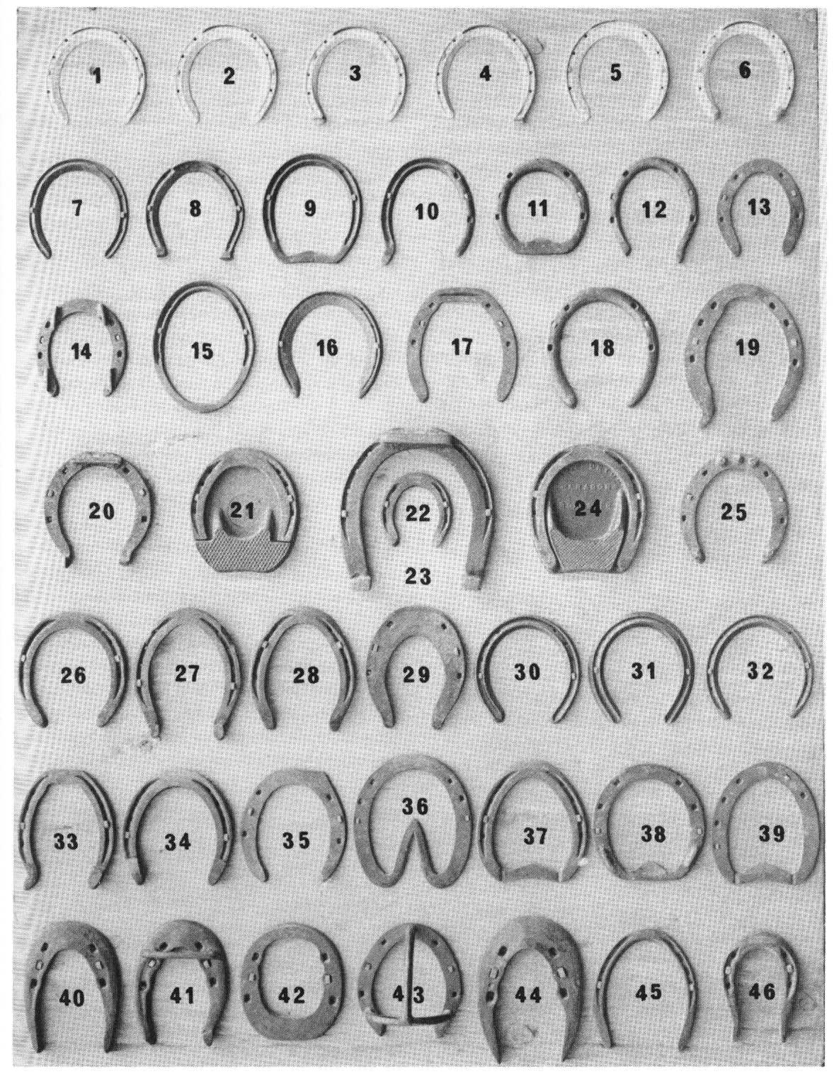

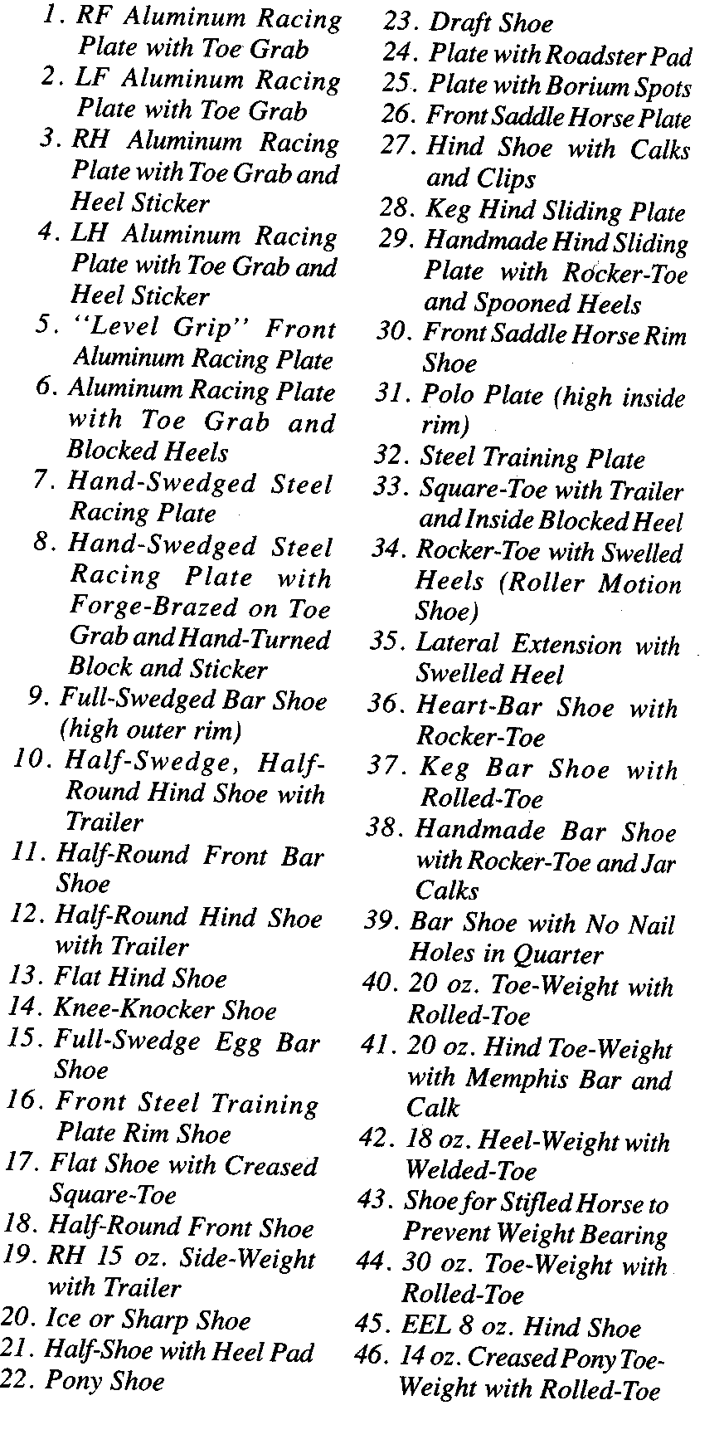
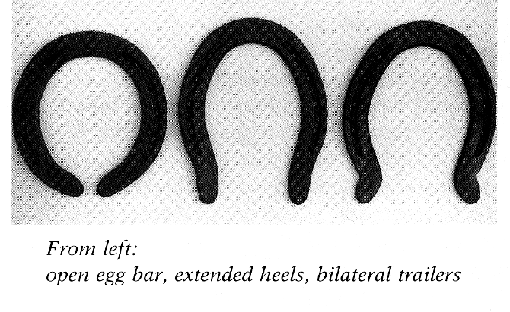
MHP - 69
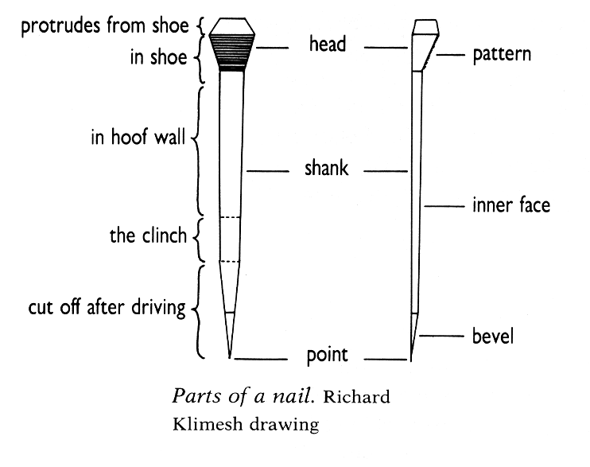
MHP- 55
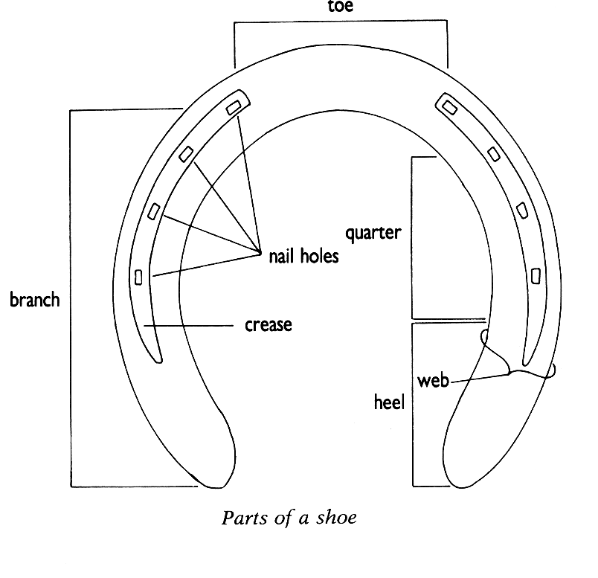
MHP - 59
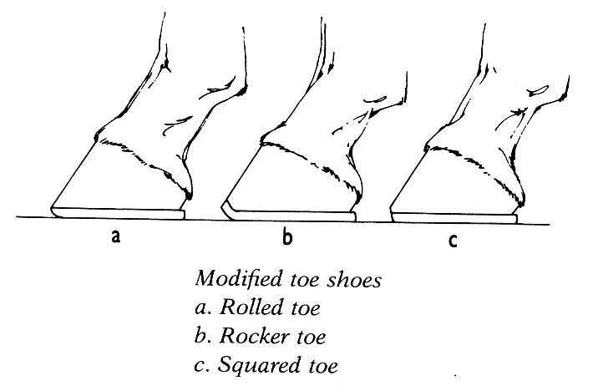
MHP - 71

FOOT AND SHOEING – B

Homework Key
25 total marks

- Name one situation where a farrier might use the following (4)
- feather edged shoe
reduce risk of interference injuries

- grass tip
on horses turned out to grass to protect wall in toe region from splitting

- wedge heel shoe
lessen angle of tendon and reduce pressure where tendon passes under navicular bone (treat navicular disease or sesamoiditis)

- quarter clips
hind shoe because there is more twisting action on the hind
if a horse over reaches a toe clip causes more damage than quarter clips

- Give one function of the following (3)
- laminae
suspends the coffin bone in a strong, hard, protective casing that can flex under pressure

- periople
keeps moisture in

- lateral cartilages
aid in the expansion of the foot

- Name the three tendons in the foot (3)
Extensor Tendon
Deep digital flexor tendon
Superficial flexor tendon

- List the six steps of shoeing and the tools used in each (12)
- Removal | buffer, driving hammer and pincers
- Preparation | knife, hoof cutter and rasp
- Forgeing | iron, anvil/hammer, pritchel
- Fitting | pritchel, hammer/anvil
- Nailing on | nails, hammer and nail block
- Finishing | clenchers, rasp, hammer

- Give three features of a hunter’s shoe (3)
- concave iron
- fullered;
- heels of fore shoe pencilled;
- toe of hind foot is rolled, set back and bevelled off, quarter clips;
- outer heel of hind shoe has calkin; inner heel of hind shoe has a wedge

FOOT AND SHOEING – B

Student’s Guide

Part I –Function of Foot
Purpose
- Know the six function of the foot
- Begin learning the details of each function

(USAB – 274-275 and additional references as indicated)
Function | Description
 | (MHP – 10)
 | (MHP – 14)
 | (MHP – 10 )

Part II -- Structures of the foot
Purpose
- Identify the basic structures of the foot
- Begin learning the functions of each part

NOTE: every source has slightly different terminology for the different structures. Wherever possible those differences have been identified
STRUCTURE | DESCRIPTION/FUNCTION
Perioplic Ring (KYH – 6)
Periople (USAB – 256)
Coronary Band (USAB – 255)
Wall (USAB – 255)
Bars (MHP – 11) | (KYH – 7)
White Line (NZ2 – 212)
Corium (KYH – 6 and MHP – 10)
Sensitive Laminae (MHP - 10 → dermal laminae)

Coffin Bone (Pedal Bone or 3rd phalanx) (USAB–254) | (HN – 153)
Navicular Bone (distal sesamoid) (USAB – 254) | (KYH – 5, HN - 154)
Navicular Bursa (USAB – 254)
Lateral Cartilages (USAB – 256) | (VN – 232, MHP – 14)
Bulbs of heel (USAB – 256) | (MHP – 14)
Digital Cushion (pedal or plantar cushion) | (HN – 155, HN – 155, MHP – 14, USAB – 255 & 275)
Frog (including functions –5) (HN 152) | (USAB – 256)
Sole (USAB – 256)

Extensor Tendon (HN – 154)
Deep Flexor Tendon (HN – 154; USAB – 254)
Superficial Flexor Tendon (HN – 154)
Suspensory Ligament (HN – 154)
3 bones of the foot
3 tendons of the foot
Ligament of the foot

DIAGRAMS OF THE FOOT

Maximum Hoof Power - 11
Maximum Hoof Power - 11
USPC A/B - 255

Part III – Care of the Foot
Purpose
- Understand the care of the shod and unshod hoof

General
Basic hoof care routine (5 points)

MH 233 and 377
Care of shod foot

MHP 219
Hoof Examination Routine

MHP 225
Care of the unshod foot  MH – 231 | Working
Care of the unshod foot  MH – 231 | At grass
Care of the unshod foot  MH – 231 | Young stock

Part IV – Shoeing Tools
Purpose
- Recognize farrier tools and specify use

Diagrams from MH edition 10 page 211 descriptions from USC – 253 and additional references as indicated
Name | Diagram  (MH) | Description/Use
Buffer or Clinch Cutter
Pincers or Shoe Pullers
Rasp
Drawing knife or Hoof knife |  | (HN – 162)
Hoof Cutter/Trimmers or Nippers
Pritchel |  | (HN – 162)
Hammer |  | (HN – 161)
Nail Clencher |  | bends and flattens clenches into hoof wall
Crease Nail Puller |  | (MHP – 27)

Part V – Hot Shoeing vs. Cold Shoeing
Purpose
- Ability to discuss hot shoeing versus cold shoeing
- Know the steps of hot shoeing (6)

Steps in Hot Shoeing (MH – 224 –226; USC – 254)
STEP | TOOLS | PROCEDURE

Comparison of Hot and Cold Shoeing (USC – 254 and additional references as indicated)
 | DESCRIPTION | ADVANTAGES | DISADVANTAGES
Cold Shoeing |  |  | (HN – 15)
Hot Shoeing

Part VI – Indications for Need to Reshoe

Part VI – Shoeing Quality
Purpose
- Identify and discuss characteristics of good and bad shoeing
- Know the indications of need for reshoeing

Signs of Good Shoeing (11)

USC – 256
MH 227
Signs of Poor Shoeing (6)

USC 256
Reshoeing (6)

(HN – 159)

Part VII – Shoes
Purpose
- Identify parts of the shoe and specific shoes including their type, purpose and other characteristics
- Able to discuss advantages and disadvantages of traction devices (not details on specific studs and their uses)
- Able to discuss the purpose of clips (both toe and quarter)

Terminology
Term | Definition
feathering

(USAB – 284)
concave

(HN – 159
fullered/creased/
swedged
calkin or calk

(HN – 159)
wedge

(MH –228)
pencilled
trailer

(USAB – 284)
relieve or seat | (MHP – 32)
safed off | (MH – 228)
keg shoe | (MHP – 58)

Materials
Material | Advantage | Disadvantage
Steel
Aluminum (MHP – 57)
Titanium (MHP – 58)
Plastic (MHP – 58)
Combination of steel/aluminum and plastic or rubber (MHP – 58)

Basic Shoe Types (MHP 61 - 71 and additional sources as indicated)

TYPE | USE | DESCRIPTION | NOTES
Stamped shoe | (HN – 159) | HN – 159; MH - 227)
Plain shoe | (HN – 159)
Hunter Shoe  (HN – 159) |  | (MH – 227)
Concave shoe

(USC – 259)
Feather-Edged Shoe (HN –160) or Anti-brushing Shoe (MH – 229) |  | (USAB – 284) | fitting (MH – 229)
Wide Web shoe or Broad Web Shoe | (MH – 229)

Grass Tips

(HN – 161)
Rim Shoe
Polo Shoe |  | MHP 61, USAB – 285
Barrel racing shoe
Wedge shoe (swelled heel) | (HN – 175)
Toed and heeled
Racing plate |  |  | see also USAB – 285
Surgical Shoe

(MH – 229)
Bar Shoes (General) | (USAB – 284)
Egg Bar
Heart Bar
Full Support Shoes
Extended heel shoes (MHP – 68) |  |  | Trailer (USAB – 284)
Squared Toe (MHP – 70) | (USAB – 284)
Roller Toe (MHP – 70; USAB – 285)
Rocker Toe (MHP – 70; USAB - 285)
Roller-Motion Shoe (MHP – 70)
Half-round Shoe (MHP – 70)

 | Description
Heels or calks

USAB – 286-288
Borium

USAB – 286-288
Tapped shoes with Removable Studs (screw-in calks)

USAB – 286-288
Clips  NZ2 – 10 | Quarter
Clips  NZ2 – 10 | Toe

Shoe Diagrams
MHP- 55
MHP - 59
MHP - 71

FOOT AND SHOEING – B

Homework

- Name one situation where a farrier might use the following (4)
- feather edged shoe

- grass tip

- wedge heel shoe

- quarter clips

- Give one function of the following (3)
- laminae

- periople

- lateral cartilages

- Name the three tendons in the foot (3)

- List the six steps of shoeing and the tools used in each (12)

- Give three features of a hunter’s shoe (3)

