SADDLERY – B

Instructor’s Guide

Part I – Snaffle Bits
Purpose
- Understand terminology relating to snaffle bits
- Describe the action of a snaffle bit
- Understand the proper fitting of the snaffle bridle
- Be able to identify types of snaffles
Teaching Suggestions
- A list of all points of action of bits is included so students can see that snaffles act only a portion of the whole list.
- Review each bit in chart and accompanying description/action.
- Bring bits if possible.

Snaffle Bit Terminology
Snaffle Definition | - two rings connected by a mouthpiece (USAB 428)
Bradoon | - a snaffle used in a double bridle → ring must not exceed 8 centimeters (3 1/8 inches)
Other names for snaffle | - direct pressure  - non-leverage bits
Parts of the Snaffle | - Ring Type  - Mouthpiece Type  Both parts must be used when describing a bit

Action of the Snaffle
Principal Areas of Snaffle Action  MH 303 | - Lips and corners of mouth  - Bars  - Tongue
7 points of bit action  Applies to bits in general  Will be required in future levels.  MH 301 | - Lips and corners of mouth  - Bars of mouth  - Tongue  - Roof of mouth  - Nose  - Chin groove  - Poll

Fitting the Snaffle (and Pelham)
Width | - when the joint is straight in the horse’s mouth, ¼ inch should protrude from each side (more if bit has cheekpieces) MH – 302
Height | - by gently pressing both sides of the bit down at corners than adjust bridle cheekpieces so that the bit makes the horse smile but does not unduly wrinkle the corners of the mouth. MH – 302

Describing Snaffle Bits
NAME | DESCRIPTION
Loose ring | Allows mouthpiece to slip around the ring → encourages horse to relax jaw, chew bit and make foamy saliva.  If holes are large, may pinch corners of lips. | 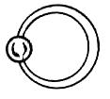USAB - 429
Egg butt (Barrel Head) | Extended joint prevents pinching of lips.  Bit is more stable in mouth and rotates less freely than loose ring. | 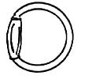 USAB – 429
Dee-Ring (Racing) | Joint extended to upper ends of the “dee”  Non-pinching but tends to fix the bit in the mouth  Sides of the dee have a lateral guiding effect in turns | 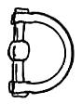 USAB – 429
Full Cheek | Cheeks extend up and down from mouthpiece, preventing the bit from slipping sideways through the mouth and exerting lateral control for turns  Keepers should be used → decrease risk of horse catching the upper cheek on an obstruction  Keepers fix bit in mouth and concentrate pressure on bars and tongue | 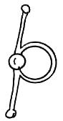USAB – 429
Half Cheek | Has upper or lower cheeks only.  Similar to full cheek.  Lower cheek in driving and racing bridles to prevent cheeks from becoming caught on harness or starting gate.  Upper cheek bits are permitted in dressage. | 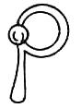USAB – 429
Hanging Cheek (Baucher) | Snaffle ring with upper cheek and bridle ring.  fixes the bit in the mouth, concentrating pressure on bars  Sometimes used as preparation for a curb. | 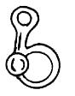 USAB – 429
Fulmer | Full cheek with loose ring.  Permits more free play than conventional full cheek but has lateral guiding effect. | 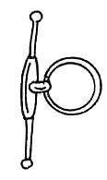 USAB - 429
Single Jointed, Standard Weight | Action: tongue, lips and bars with nutcracker action.  Mild to moderate.  Permitted in dressage competition. | 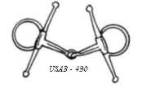
Thick (Hollow Mouth, German) | Usually single jointed.  Action: spreads pressure over wider surface.  Some horses have small mouths that cannot accommodate an extra thick bit.  Mild  Permitted for dressage | 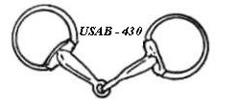
Double Jointed (French Mouth) | Smooth bone-shaped center link.  Action: lies flat on tongue; reduces pinching effect.  Flexibility makes it milder and encourages chewing and jaw relaxation.  Mild. For horses with narrow mouths (NZ2 263)  Permitted in dressage. | 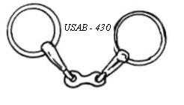
Dr. Bristol | Double jointed with a flat rectangular plate.  Placed so plate lies flat on the tongue.  Action: similar to French snaffle but with more tongue pressure.  Not permitted for dressage phase of combined training events. | 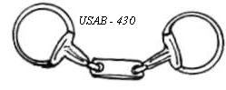
Mullen Mouth (Half Moon, Bar Snaffle) | Unjointed, solid mouthpiece with slight curve.  Action: pressure on tongue and bars across width of bit.  Some horses lean against the solid mouthpiece.  Mild.  Permitted for dressage. | 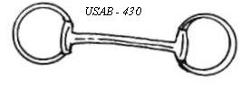
Roller (Roller Mouth, Single Roller, Cherry Roller, Magenis) | Action: rollers encourage chewing, activation of tongue and relaxation of jaw  Sometimes used to passify nervous horse.  Not permitted for dressage.  See S – 68 for the different kinds. | 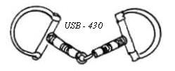
Mouthing Bit (Key Bit) | Action: keys that dangle from center link encourage horse to mouth and play with bit and relax jaw.  Used to introduce young horses to the bit  Not for dressage. | 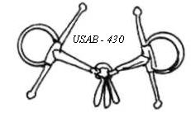
Twisted (slow twist) | Action: edges = clearly defined pressure for a stronger effect.  Severe.  Not permitted for dressage. | 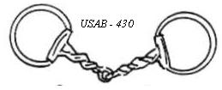
Corkscrew (Serrated) | Action: acts strongly on bars, tongue and corners or lips.  Severe.  Not permitted for dressage. | 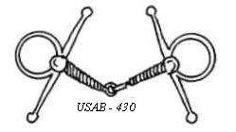
Twisted Wire (Single or Double (shown)) | Action: the thin mouthpiece and edges of wire concentrate pressure for severe, abrasive effect.  Double twisted wire has offset angles that act severely on tongue, bars and corners of mouth.  Severe.  Not permitted for dressage. | 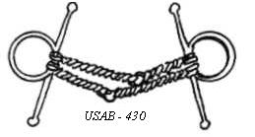
Hard Rubber Bar | S – 61: mildest form of snaffle. Used if horse is light mouthed or he is pulling because of pain. | 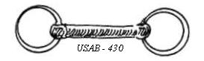

Part II – Bit Evasions
Purpose
- Know common bit evasion including likely causes
Teaching Suggestions
- Note that the New Zealand manuals are no longer on the reading lists but they provide the most complete description of bit evasions. *** check saddlery and know your horse***
- Students should recognize that

Bit evasions (NZ2 273)
Evasion | Cause
General | Always look to the rider first → that is the main cause for bit evasions
- Unsteady Head | Rider  - unsteady hands  Horse  - sinus trouble  - stiffness of discomfort in the back  - Temperament or conformation
- Above the bit | - see above
- Pulling | Rider  - allowing horse to take charge  - pulling rather than checking  - hanging on the bridle  - horse too much for rider  - nervous  Horse  - lack of training  - excitement over-keeness too much galloping
- Leaning on the Bit | Rider  - tipped forward with set, heavy hands  - insufficient use of seat and leg  Horse  - poor natural balance and/or conformation  - tired or unit  Other  - too mild a bit (especially rubber or metal half moon)
- Behind the Bit | Rider  - fixed unresponsive hands  - insufficient seat and leg  - forcing aids  Other  - too severe a bit
- Head Tilting | Rider  - uneven hands  - crossing inside hand over the neck  Horse  - one sided  - evading even contact  - sore teeth or mouth  - stiffness or discomfort in back
- Tongue over the Bit | Horse  - narrow or thick tongue  Other  - bit uncomfortable or ill fitting  - jointed snaffle to big or fitted too low

Part III – Identifying Equipment
Purpose
- Identify and know the basic purpose of various pieces of equipment
Teaching Suggestions
- Look at actual pieces of equipment as much as possible.
- While looking at the equipment try to determine what the function would be

Martingales
TYPE | USE
Standing | Use: prevents horse raising head beyond angle of control (MH – 312) | 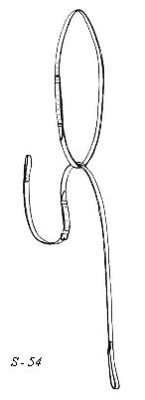
Grainger | Use: combination of noseband and martingale. Noseband is adjusted midway between position for dropped noseband and ordinary cavesson → more pressure on thenose. Used on strong horses.  Controversial  (S – 55) | 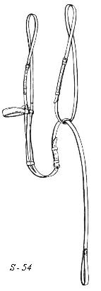
Running | Use: provides a regulating influence on a horse which carries its head too high. (MH – 314) Help to people with not so good hands (S – 57)  Notes: If used with a double bridle, the rings should be on the curb rein. Reins should be fitted with stops (MH – 314) | 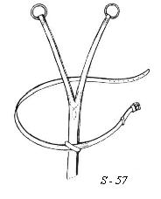
Irish | Use: keep the reins in place and prevent them from going over the horse’s head. | 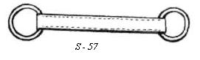
Bib | Use: combination running and irish. The bib keeps race horse from getting leg through branches (S – 37) | 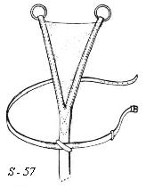
Pulley | Use: similar to running martingale but because the cord between the rings can slide back and forth, in sharp lateral movement (such as turning in jumping) it allows the horse to bend his head and neck in the required direction without the restriction against the opposite side of his mouth. | 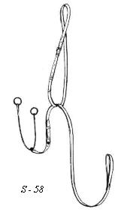
Combination Martingale | Use: combine running and standing martingales having the action of both. | 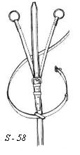
Market Harborough  S 39 | Use: a martingale body which ends at the breast in a ring to which are attached two strips of either rawhide or rounded leather. Theses two strips pass upwards, through the ring of the bit and then connected to an otherwise normal rein with an adjusting buckle. The rein tightens and exert their downward pull on the bit only when head is thrown upwards. | 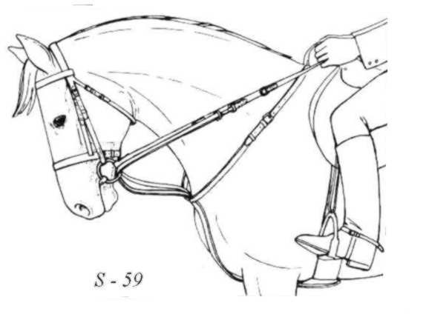

Breastplates
TYPE | USE/FITTING
Hunting Breastplate  USAB 443 | Use: Keeps saddle from sliding back but not restrict chest, shoulders or between the forelegs. | 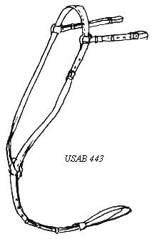
Breast Collar  USAB 444 | Use: Hold saddle more securely than breastplate and are preferred for events in which a weight pad is carried and for polo. | 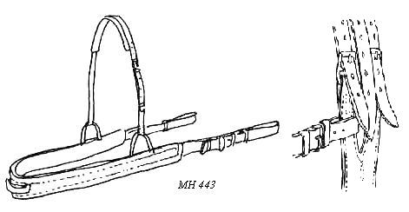
Elastic Breast Girth  USAB 444 | Use: Used mostly for show jumping as they restrict the freedom of the shoulders less than other types of breast collars. | 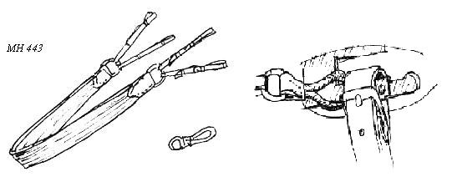

Nosebands
TYPE | USE/FITTING
Dropped Noseband | Use: for horses that try to open mouth too wide, cross jaw or draw the tongue back (MH 310) Helps the bit act on bars rather than the corners of the mouth (NZ2 270) | 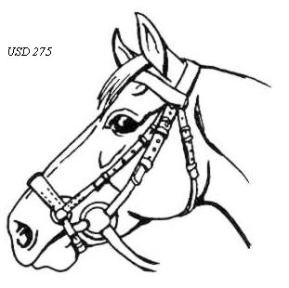
Flash Noseband | Use: a cavesson with an additional lower strap. No risk of front strap slipping down. (MH 311) | 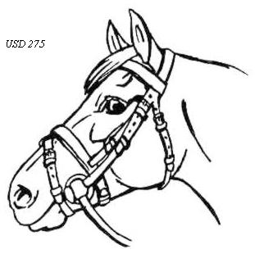
Figure Eight, Crossed or Grackle Noseband  MH 311 | Use: same purpose as drop but as additional strap above the bit. Acts over a wider area and is more effective in preventing the horse from crossing his jaw. Very practical for cross country (cannot affect his breathing). | 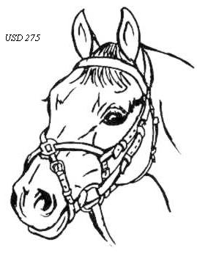
Kineton (Puckle) Noseband  MH 311 | Use: does not have a back-strap → free movement of the horse’s jaw but when correctly adjusted the effect is that the pull from the resins is partially or wholly transferred to the front of the nose. Effective on a hard puller. | 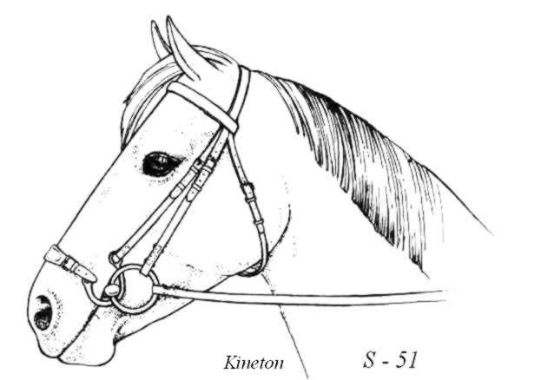

Girths
TYPE | USE
Lampwick | 8.75 cm wide woven cotton made from tubular lampwick.(S 179)
Lonsdale | Short dressage girth made of nylon/cotton materials or from leather. Be sure there is adequate ‘safe’ (backing) behind the buckles to prevent rubbing. (S 182)
String | Let air between strands, grip better than leather and therefore less likely to cause galls (MH 286) | 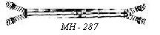
Balding | Reduces girth width behind elbows where it could cause galls. Allows straps to move on top of each other and be more comfortable (MH 286) | 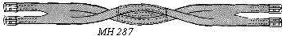
Atherstone | Same shape as balding but all one piece. (MH 286) | 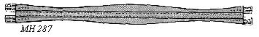
Three Fold | Folded edge should be towards front of horse (MH 286)  Dressed fabric inside keeps girth very supple and rounded front edge decreases risk of rub in elbow region. (S 180) | 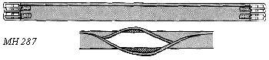
Tubular | Comfortable and strong but check stitching/strength after cleaning (MH 286) | 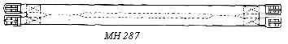
Webbing | Must always be used in pairs, do not wear well and are liable to snap without warning. (MH 286)  Should be of wool web. Require regular washing (S 181) | 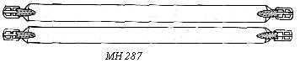
Overgirth Surcingle (S 181) | Elastic girth that is placed over the saddle and run through keepers on the outside of the girth. Keeps the flaps from shifting and increases security of saddle, especially for cross-country jumping, show jumping, racing and steeplechasing. Should always be used when a weight pad is carried. Must never be placed to prevent stirrups from coming off. (USAB 444) | 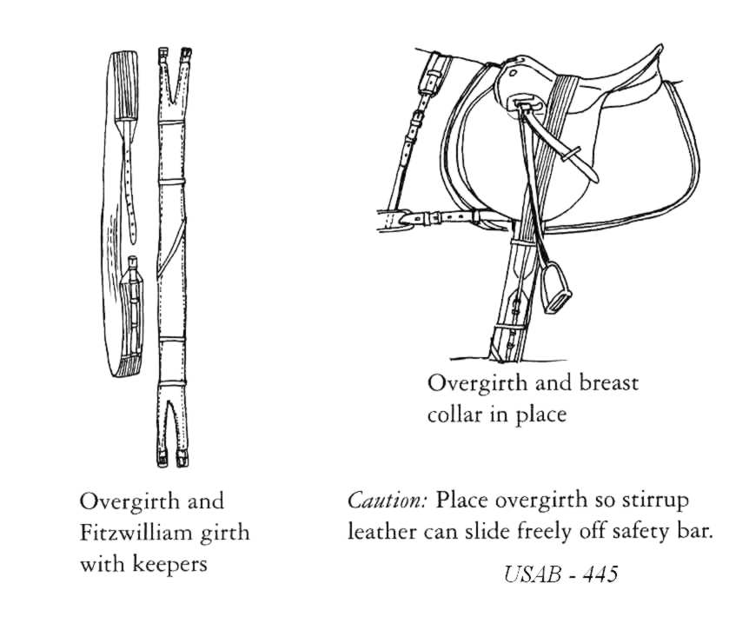

Part IV – Saddle Types
Purpose
- Know the difference between common saddle types
Teaching Suggestions
- If students know what they are designed for they will be able to describe the differences.

Common Saddle Types
Dressage  MH 278 | Purpose  - specific to dressage  - designed for riding with long stirrup-leathers  Description  - deep-seated saddle  - straight cut saddle-flap  - long straps and short girth to prevent girth lying under rider’s thigh  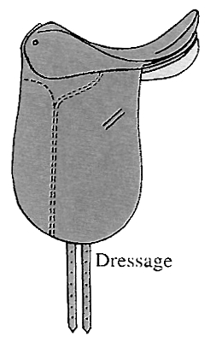
Show Jumping  MH 278 | Purpose  - riding in shorter stirrup-leathers  Description  - forward cut saddle flap  - flatter seat than dressage  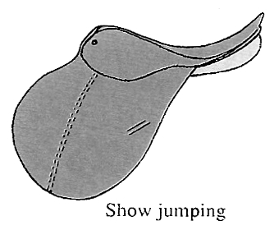
General Purpose  MH 277 | Purpose  - designed for general riding  - suitable for most Pony Club activities  Description  - saddle flaps and length of seat are mid-way between dressage and show-jumping  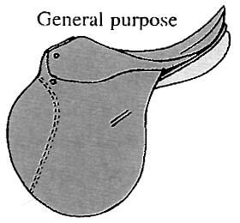
Synthetic Saddles  MH 278 | Available in many different styles and price ranges.

SADDLERY – C2

Homework Key

SADDLERY – C2

Student’s Guide

Part I – Snaffle Bits
Purpose
- Understand terminology relating to snaffle bits
- Describe the action of a snaffle bit
- Understand the proper fitting of the snaffle bridle
- Be able to identify types of snaffles

Snaffle Bit Terminology
Snaffle Definition

USAB 428
Bradoon
Other names for snaffle
Parts of the Snaffle

Action of the Snaffle
Principal Areas of Snaffle Action

MH 303
7 points of bit action  Applies to bits in general  Will be required in future levels.  MH 301 | - Lips and corners of mouth  - Bars of mouth  - Tongue  - Roof of mouth  - Nose  - Chin groove  - Poll

Fitting the Snaffle (and Pelham)
Width

MH 302
Height

MH 302

Describing Snaffle Bits
NAME | DESCRIPTION
Loose ring |  | USAB - 429
Egg butt (Barrel Head) |  | USAB – 429
Dee-Ring (Racing) |  | USAB – 429
Full Cheek |  | USAB – 429
Half Cheek |  | USAB – 429
Hanging Cheek (Baucher) |  | USAB – 429
Fulmer |  | USAB - 429
Single Jointed, Standard Weight
Thick (Hollow Mouth, German)
Double Jointed (French Mouth)
Dr. Bristol
Mullen Mouth (Half Moon, Bar Snaffle)
Roller (Roller Mouth, Single Roller, Cherry Roller, Magenis)
Mouthing Bit (Key Bit)
Twisted (slow twist)
Corkscrew (Serrated)
Twisted Wire (Single or Double (shown))
Hard Rubber Bar

Part II – Bit Evasions
Purpose
- Know common bit evasion including likely causes

Bit evasions (NZ2 273)
Evasion | Cause
General | Always look to the rider first → that is the main cause for bit evasions
- Unsteady Head | Rider  Horse
- Above the bit
- Pulling | Rider  Horse
- Leaning on the Bit | Rider  Horse  Other
- Behind the Bit | Rider  Other
- Head Tilting | Rider  Horse
- Tongue over the Bit | Horse  Other

Part III – Identifying Equipment
Purpose
- Identify and know the basic purpose of various pieces of equipment

Martingales
TYPE | USE
Standing  MH 312 | Use: prevents horse raising head beyond angle of control (MH – 312)
Grainger

S 55
Running

MH 314
S 57
Irish
Bib

S 37
Pulley
Combination Martingale
Market Harborough

S 39

Breastplates
TYPE | USE/FITTING
Hunting Breastplate

USAB 443
Breast Collar

USAB 444
Elastic Breast Girth

USAB 444

Nosebands
TYPE | USE/FITTING
Dropped Noseband

MH 310

Flash Noseband

MH 311
Figure Eight, Crossed or Grackle Noseband

MH 311
Kineton (Puckle) Noseband

MH 311

Girths
TYPE | USE
Lampwick  S 179 | 8.
Lonsdale

S 182
String

MH 286
Balding

MH 286
Atherstone

MH 286
Three Fold

MH 286
S 180
Tubular

MH 286
Webbing

MH 286
S 181
Overgirth (Surcingle)

S 181
USAB 444

Part IV – Saddle Types
Purpose
- Know the difference between common saddle types

Common Saddle Types
Dressage  MH 278 | Purpose  Description
Show Jumping  MH 278 | Purpose  Description
General Purpose  MH 277 | Purpose  Description
Synthetic Saddles

MH 278

SADDLERY – C2

Homework

