**Pony Club Testing – An overview**

Testing is simply a way members can take part and demonstrate their knowledge of horses through a testing system that is run in three separate phases. If you don’t meet the standard on a certain phase you simply try again!

Testing is NOT a requirement, however, in order to test you must have attended at least 60% of the pony club lectures/clinics run by your branch. (Winter Program)

For anyone wanting to try testing the Branch will provide an “application to test”. It will need to be completed and signed by the member’s instructors verifying that they meet the criteria to test at a certain level.

***The Phases of testing***

Phase 1 – written test published by Canadian Pony Club each year, and provided to the various branches in May and again in October (if they do both Spring and Fall tests). The club test representative will set a test date and location for the written tests once they are provided to the branch. OLD tests for the members to practice so they can see what kind of information they are expected to know for the various levels can also be provided if members wish to study.

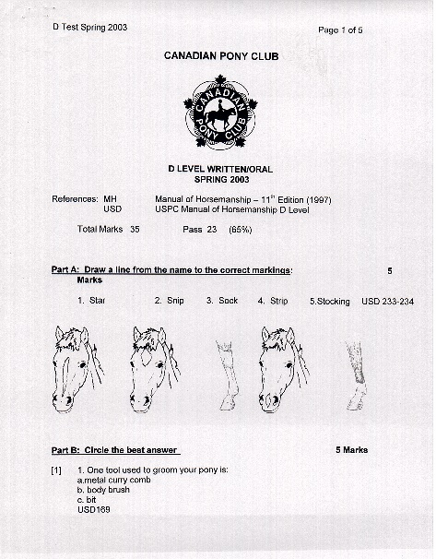

YOU MUST PASS THE WRITTEN WITH A 65% OR HIGHER IN ORDER TO CONTINUE TO PHASE 2 SM

Phase 2 – Stable Management (hands on) IF YOU HAVE PASSED THE WRITTEN WITH A 65% OR HIGHER you may move onto the stable management portion where you demonstrate your knowledge by speaking with various examiners who will discuss items with you to see how much you know. This is hands on so you will have to identify actual parts of the horse on the horse instead of on pictures. This also stands for parts of the saddle and bridle etc….. It will be the real thing, not pictures. You will also be asked to demonstrate certain things for the level you choose to test to. For example: for D1 you will be asked to demonstrate leading a horse. In D2 you will be asked to demonstrate putting on a saddle.

Each level has different requirements and there are lists to help you along the way.

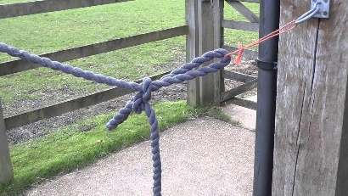 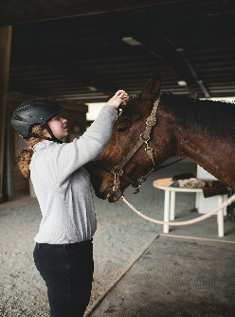

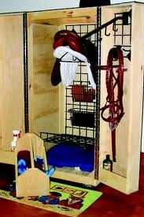

Phase 3 – Riding ( ONLY IF YOU HAVE PASSED THE STABLE MANAGEMENT STAGE)

Once you have passed the Stable Management phase you can continue onto the riding phase. If you choose to do ALL 3 sections of riding; flat, stadium jumping and cross country jumping this is called the “traditional stream”

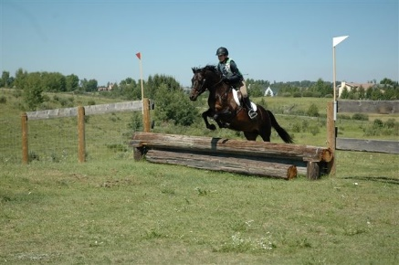

HOWEVER, if you do not wish to do any jumping you can stream “flat”. If you wish to do flat and stadium but NO cross country you can stream “flat & stadium”. They have made it so you can basically do what you are comfortable with.

***The Levels*** – Members start at D and work their way up through the levels  
D, D1, D2, C, C1, C2, B, B2, A (In regular testing (not challenge) you may test 2 levels in one year)

***Multiple level FIRST TEST***

For a **new** member who has **never tested** you may challenge several levels.  Members often choose to challenge D and D1. Some may choose to challenge D, D1, D2, however you never have to challenge if you don’t want to.  There is no rush, you can simply do D if you like.

***Location for Testing.*** Branches may run testing at their home property (if they can secure examiners to complete the test) for levels up to C2 OR they may attend Regional D thru C1 testing hosted by Alberta South Region. This is usually run at Delacour just East of the City of Calgary.

***Streaming***

As mentioned earlier if you hear reference to “traditional stream” it includes all three phases of riding; flat, stadium jumping and cross country jumping.

If you have a member who would like to test but has reservations with cross country or jumping all together you can stream flat and never have to do jumping.

Some members may choose to do flat and stadium and never do cross country.

There are various streaming options to choose from, which helps include everyone.

If you ever have any questions please do not hesitate to drop me an email or a text.

You will hear from me again around end of April or beginning of May when the written tests are produced by Canadian Pony Club

SPC Club Test Rep

Lois Booy

Cell 403 801 2041